**ELEC 558-Project**

Sichao Zhang

1. **Problem Description**

This project is aimed to generate the low pass filter using Remez-exchange algorithm and apply it to the ‘peppers’ poly phase problem. The conventional filters applied to this problem has the limitation that when filtering the upsampling frequency response, they may amplify the magnitude at the frequency $\frac{2π}{32}i$ (*i=1,2…16*). So, the new filter will be designed to set magnitude at these frequencies zero.

1. **Algorithm**

The new filter is based on the Parks-McClellan theorem and Remez-exchange algorithm.

Remez-Exchange Algorithm:

Step 1: Select an initial set of (L+2) extremal frequencies, {$ω_{0}^{0}$, $ω_{1}^{0}…ω_{L+1}^{0}$};

Step 2: Calculate $ϵ^{k}=-\frac{\sum_{i=0}^{L+1}{γ_{i}\tilde{D}\left(ω_{i}\right)}}{\sum_{i=0}^{L+1}{\frac{γ_{i}{\left(-1\right)}^{i}}{\tilde{W}\left(ω_{i}\right)}}}$;

Step 3: $P\left(ω_{i}\right)=\tilde{D}\left(ω_{i}\right)+\frac{{\left(-1\right)}^{i}ϵ}{\tilde{W}\left(ω_{i}\right)}$;

Step 4: Evaluate $P\left(ω\right)=\sum_{0}^{L}{P\left(ω_{i}\right)f_{i}(ω)}$, with $f_{i}\left(ω\right)=\prod_{\begin{aligned}j=0 \\ j≠i\end{aligned}}^{L}{\frac{\cos\left(ω\right)-cos⁡(ω_{j})}{\cos\left(ω_{i}\right)-cos⁡(ω_{j})}}$ at a dense of frequencies;

Step 5: Evaluate $ϵ\left(ω\right)=\tilde{W}\left(ω\right)[P\left(ω\right)-\tilde{D}\left(ω\right)]$ on the dense set of frequencies, and identify (L+2) new candidates for extremal frequencies;

Step 6: If $|ϵ(ω_{i}^{k})|$ are all equal, algorithm has converged; else, go to step 2.

In order to set the magnitude at $\frac{2π}{32}i$ zero, which means we should add 16 more frequencies to the first guess and set $P\left(ω_{i}\right)=0$ for them.

1. **Implementation**

The length of the final filter is $3×32+1=97$, so L is 48. The first guess of filter is 50 frequencies uniformly distributed among 0 to 3.14. Then I add $\frac{2π}{32}i$ to the first guess and set their $P(ω)$ to zero, after that, apply them to the rest of steps. The result of first iteration is shown in Figure 1.

There are 63 elements in the new $ω$ generated from extremals in response, which indicates that the algorithm takes extra frequencies into account. So, I take off 13 more frequencies which are closed to $\frac{2π}{32}i$ manually.

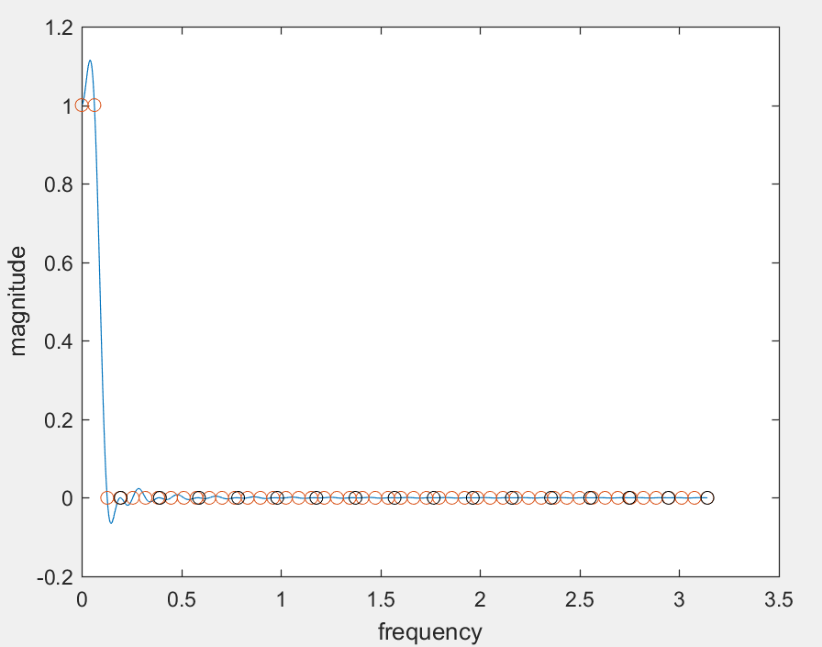

Figure 1 First Iteration of Modified Remez-Exchange Algorithm

In this way, the Modified Remez-Exchange Algorithm becomes:

Step 1: Select an initial set of (L+2) extremal frequencies, {$ω_{0}^{0}$, $ω_{1}^{0}…ω_{L+1}^{0}$};

Step 2: Add $\frac{2π}{32}i$ (*i=1,2…16*) to the (L+2) extremal frequencies, and sort them.

Step 2: Calculate $ϵ^{k}=-\frac{\sum_{i=0}^{L+1}{γ_{i}\tilde{D}\left(ω_{i}\right)}}{\sum_{i=0}^{L+1}{\frac{γ_{i}{\left(-1\right)}^{i}}{\tilde{W}\left(ω_{i}\right)}}}$;

Step 3: $P\left(ω_{i}\right)=0 (ω_{i}=\frac{2π}{32}i),P\left(ω_{i}\right)=\tilde{D}\left(ω_{i}\right)+\frac{{\left(-1\right)}^{i}ϵ}{\tilde{W}\left(ω_{i}\right)} (for others)$;

Step 4: Evaluate $P\left(ω\right)=\sum_{0}^{L}{P\left(ω_{i}\right)f_{i}(ω)}$, with $f_{i}\left(ω\right)=\prod_{\begin{aligned}j=0 \\ j≠i\end{aligned}}^{L}{\frac{\cos\left(ω\right)-cos⁡(ω_{j})}{\cos\left(ω_{i}\right)-cos⁡(ω_{j})}}$ at a dense of frequencies;

Step 5: Evaluate $ϵ\left(ω\right)=\tilde{W}\left(ω\right)[P\left(ω\right)-\tilde{D}\left(ω\right)]$ on the dense set of frequencies, and identify (L+2) new candidates for extremal frequencies from taking off the frequencies that are closed to $\frac{2π}{32}i$;

Step 6: If $|ϵ(ω_{i}^{k})|$ are all equal, algorithm has converged; else, go to step 2.

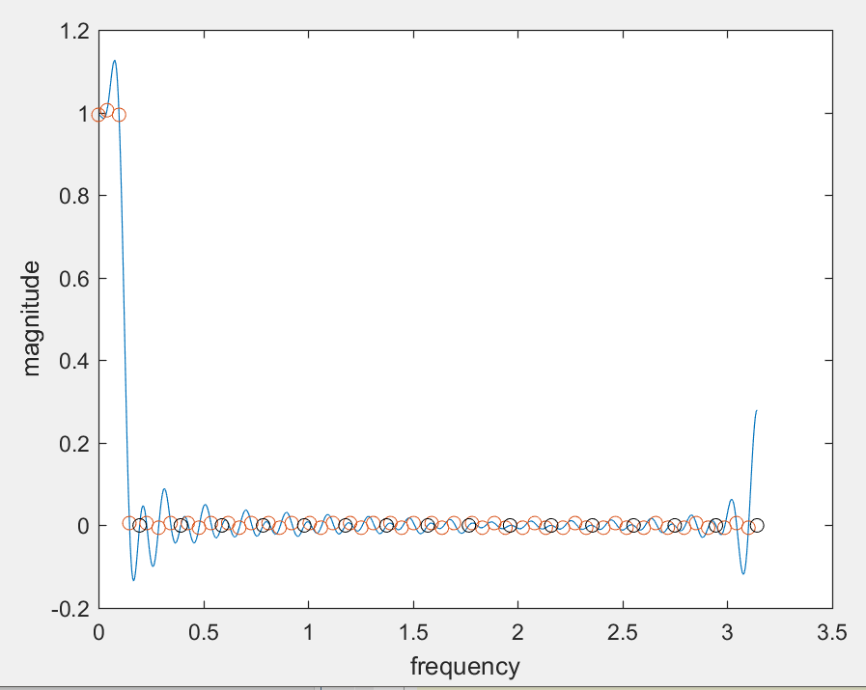

Figure 2 Second Third Iteration of Modified Remez-Exchange Algorithm

After three iterations, the frequency response is shown in Figure 2. The response blows up in high frequency but works well in low. So, I decide to use this generation of $ω$ to build the filter, which is ‘omegas_13.mat’ in the file.

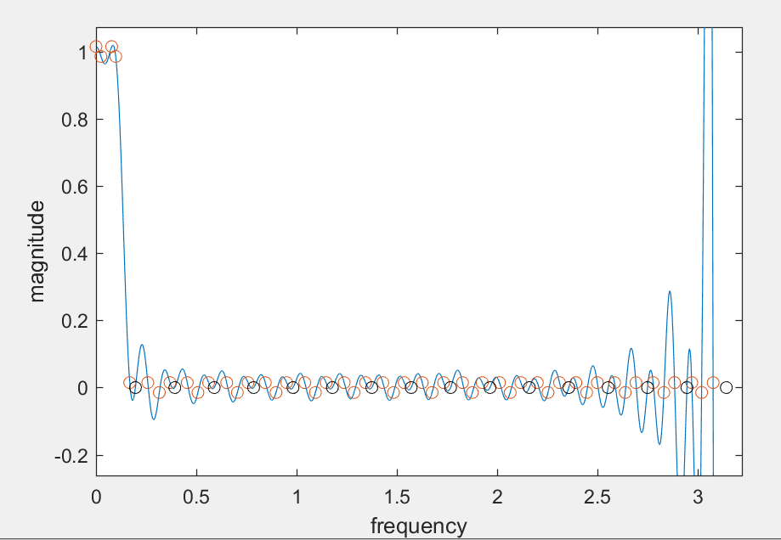

Figure 3 Third Iteration of Modified Remez-Exchange Algorithm

However, I failed to recover the elements of the filter… My generation code does not work in this case.

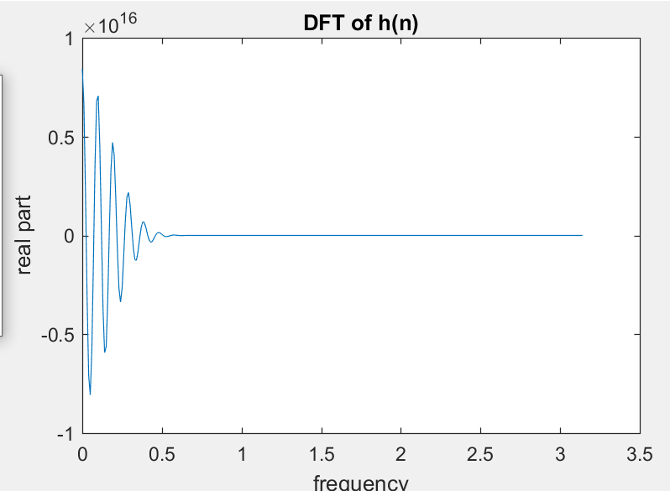

Figure Failure Figure of $H_{d}(ω)$